**Codecademy Task – Simon Barry**

Last page of the HTML learning path:

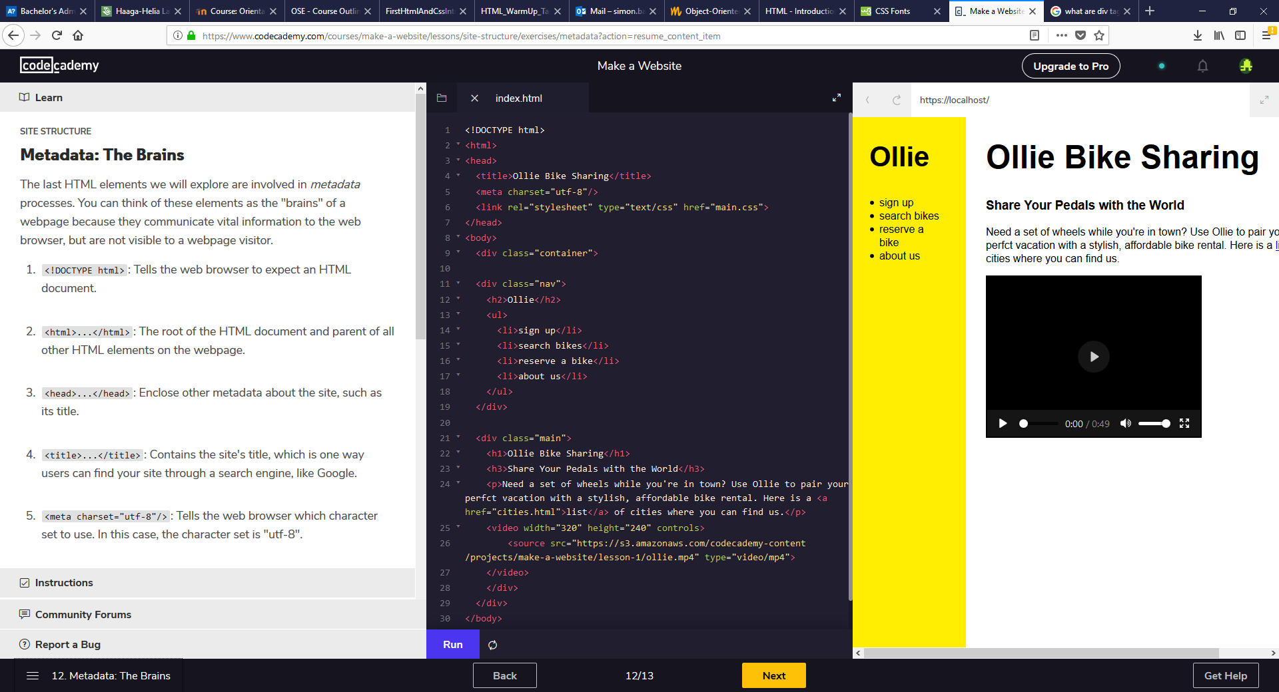

HTML Quiz:

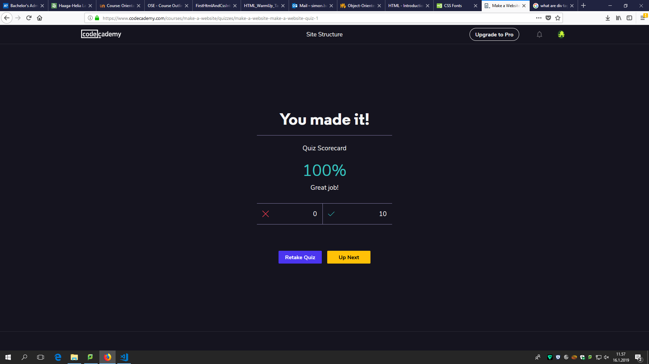

Last page of the CSS learning path:

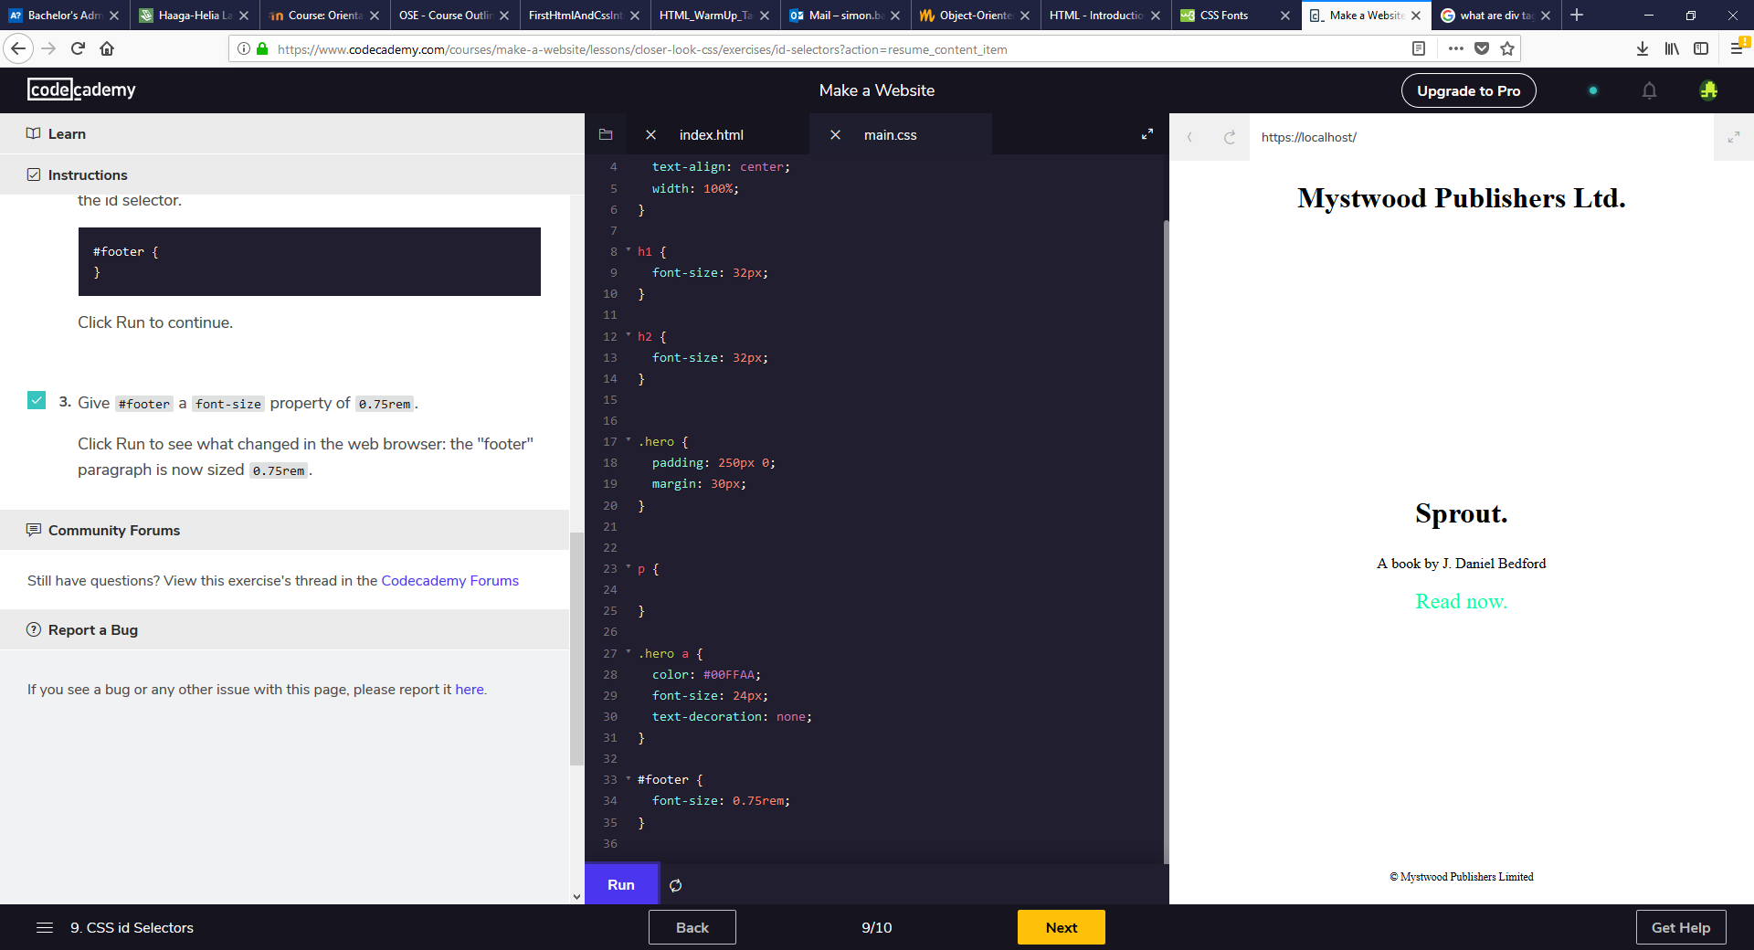

CSS Quiz:

